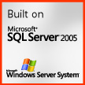
Hands On Training Lab
SQL Server Integration Services 2005
V1.2
1. Hands-on Labs Overview 3
2. Setup and Congfiguration 4
3. Hands-on Lab I (Short data trouble shooting package) 5
3.1. Hands-on Lab Preset 5
3.2. Hands-on Lab Details 5
3.3. Conclusion 12
3.3.1. Comments 12
3.3.2. BOL 12
4. Hands-on Lab II (Create text files from adventure works table then loop to load them) 13
4.1. Hands-on Lab Preset 13
4.2. Hands-on Lab Details 13
4.3. Conclusion 22
4.3.1. Comments 22
4.3.2. BOL 22
5. Hands-on Lab III (Expand loop to write iteration audit information) 23
5.1. Hands-on Lab Preset 23
5.2. Hands-on Lab Details 23
5.3. Conclusion 25
5.3.1. Comments 25
5.3.2. BOL 25
6. Hands-on Lab IV (Open a different application based on day of week) 26
6.1. Hands-on Lab Preset 26
6.2. Hands-on Lab Details 26
6.3. Conclusion 27
6.3.1. Comments 27
6.3.2. BOL 27
7. Hands-on Lab V (Extend LoadApplications to feed it application names with a configuration file) 28
7.1. Hands-on Lab Preset 28
7.2. Hands-on Lab Details 28
7.3. Conclusion 30
7.3.1. Comments 30
7.3.2. BOL 30
8. Hands-on Lab VI (Error Rows and logging data) 31
8.1. Hands-on Lab Preset 31
8.2. Hands-on Lab Details 31
8.3. Conclusion 36
8.3.1. Comments 36
8.3.2. BOL 36
9. Hands-on Lab VII (Deploy packages and execute from Management Studio) 37
9.1. Hands-on Lab Preset 37
9.2. Hands-on Lab Details 37
9.3. Conclusion 42
9.3.1. Comments 42
9.3.2. BOL 42
10. Hands-on Lab VIII (Add Execute SQL to truncate table to the LoopAndLoadProductionTable package) 43
10.1. Hands-on Lab Preset 43
10.2. Hands-on Lab Details 43
10.2.1. Comments 46
10.2.2. BOL 46
11. Appendix A Where to learn more 47
12. Appendix B sample Reports for SSIS Log Providers (OnPipeline Rows sent and 48
12.1. General Log summary, history, results. 48
12.2. Detailed package log history report 49
12.3. Detailed Pipeline report 50
12.4. Error Row Report 51

Hands-on Labs Overview
- Introduction
SQL Server Integration Services (SSIS), the successor to DTS in SQL Server 2005, is an all-new application that provides a data integration platform from easy-to-use tasks and transforms for the non-developer to a robust object model supporting creation of custom tasks data transformations. With the SSIS platform you can create solutions integrating data from non homogenous data sources, cleansing, and aggregation as well as work flow surrounding the data processing. SSIS goes beyond standard ETL processing (Extract Transform Load) providing components such as Web Service, XML, WMI tasks, and many more. Add to the rich list of out of the box components a full object model underneath, and users can create their own tasks, transformations, data sources/destinations, and Log Providers to suit almost any scenario.

- Audience and Pre-requisite knowledge
- Users understand the roles and differences between the applications "Business Intelligence Development Studio" and "SQL Server Management Studio".
- Users have basic understanding of SQL Server Integration Services functionality and for example have a basic understanding of the difference between "Control Flow" and "Data Flow" as well as know what "Log providers", "Connection Managers", "Property Expressions" do. I am looking for students to be familiar with the terms and the general idea of all of the things mentioned above. It’s ok if you have never played with them, just want terminology and general purpose to be familiar.
- SQL Server Business Intelligence studio is used to create, edit, trouble shoot packages while the command line tool ‘dtexec.exe’ is what you will execute packages with in production environments.

Someone can gear up on the above topics from the SSIS portal on MSDN.
http://msdn.microsoft.com/SQL/sqlwarehouse/SSIS/default.aspx
Where they can find links to the following two webcasts as well as other webcasts and articles.
- Introducing SQL Server Integration Services for SQL Server 2005 (Level 200)
- TechNet Webcast: Deploying, Managing and Securing Integration Services (Level 300)

- Scenarios
- This Lab is comprised of several smaller labs to better cover various portions of the SSIS product as well as provide natural checkpoint for the training such that if a particular exercise cannot be completed they still participate in later exercises.

Setup and Congfiguration
- Installation
- Extract the zip file to the root c:\ so you end up with “C:\_SSIS_Training”.
  - Attach the following 2 databases. “SSISLOGGING.mdf” for audit and logging data (tables myfileaudit and ssis_ErrorRows)and database “SSISTRAINING.mdf” (tables mydescriptions) for data destination.
  - We will be using data from the AdventureWorks which ships with SQL 2005 (optional during installation)

- Sql Server Books Online (BOL)
- The BOL topics noted through the doc with the icon above were found with BOL filtered to just search the “Technology” Integration Services, from the BOL Search Page.
- Miscellaneous
- You may want to have a soft copy of this manual, which can be handy to have open while you do the labs, to allow you to copy/paste expressions from the manual to the Visual Studio design environment.

Hands-on Lab I (Short data trouble shooting package)
- Purpose of Hands-on Lab
  - The purpose of this lab is to provide a quick sample/best practice on how to trouble shoot data within a package flow and to address common questions on ‘how to breakpoint and step through data in the flow’. We will load a contact table as the source data and parse out a portion of the email field, viewing the data to insure our parse expression is correct before connecting any ‘real’ destinations.
  - This exercise will be more detailed than others on exactly what to click and type as a form of introduction, while the other labs will have more generalized instructions.
  - This lab will also allow us to gauge the overall pre-knowledge of the students.

Hands-on Lab Preset
- Configuration
  - We will be using data from the AdventureWorks sample database which ships with SQL Server 2005.

Hands-on Lab Details
 | Discussion Points | Actions taken
1 | Create a new SSIS project and solution.  - During this training we will build several packages within a single solution. Remember the BI Studio is really Visual Studio 2005. The solution can contain several projects (packages) as well as Reporting services reports, Analysis Services projects…..  - SSIS packages are by default XML files with .dtsx extension. The file has a name as well as the package has a name ‘property’. Typically you will want them to be the same.  - The ‘file’ used for the package can have a different name than the ‘object’ which is the ‘Name’ property within the package. | - Open SQL Server Business Intelligence Studio (BIDS).  - Select ‘Create’ in the ‘Recent Projects’ window.  - Select ‘Integration Services’ template.  - Name of “SSISTraining” (this will be the name of the overall solution).  - Location of existing folder “C:\_SSIS_Training”.  - Check the ‘Create Directory For Solution’ box.  - Click ‘Ok’ and the Solution will be created.  - In the Solution Explorer window Right click the default package name of ‘Package.dtsx’ and select rename.  - Use name “TroubleShootDataInFlow.dtsx” and press <Enter>. Select yes to renaming the pack object as well.
2 | Add a Data Flow Task to the package  - The data flow task is a separate task that is the overall data ‘pipeline’. | - From the Toolbox, Double-click or drag the ‘Data Flow Task’ to the Control Flow canvas.  - Double-Click the Data Flow Task OR click the Data Flow tab to open the task.
3 | Add and configure and OLE DB source adapter to the data flow.  - The Connection manager handles the low level hand shake sort of exchange with your data source while the source adapter handles the data itself, such as which of the fields to actually use. | - From the Toolbox Double-click or drag the OLE DB Source to the Data Flow Task.  - Double-Click the OLE DB Source to Open it.  - In the top ‘Provider’ drop down list we want to leave it at “OLE DB\SQL Native Client” but drop the list so you can see all the choices that ship out of the box.  - Click the ‘New’ Button to add a new Connection Manager.  - Click ‘New’ in the ‘Configure OLE DB Connection Manager’ dialog.  - Enter your computer name, for example‘DBIL405’.  - Select Database name ‘AdventureWorks’.  - Click ‘Test Connection’ to insure the connection works then ‘ok’ to the test, Connection Manager, and Configure Connection Manager dialogs.  - Leave Data Access Mode as ‘Table or View’.  - In the box below, select the table [Person].[Contact].  - NOTE: In the left pane click ‘Columns’. If you wanted to remove some columns from the flow you can uncheck them now to minimize data flowing down. Leave all columns Checked for our lab We will look at error rows in a later lab.  - Click OK.
4 | Add a Derived Column Transform to the dataflow  - Double-Clicking will automatically connect the new object to the previous object, assuming its still selected. If not select the upstream object and drag the green ‘output’ arrow to the object below.  - We want to parse out a portion of the EmailAddress, the characters left of the “@”. We will start by just “deriving” what character position # the “@” symbol is at.  - The Derived Column transform allows us to ‘create’ or derive new columns from existing columns and variables.  - Note: the arrows inside the ‘Data Flow Task’ deal with data and error outputs while in the Control flow they are precedent constraints (success, failure, complete). We look a bit at each later, but see the Suggested BOL topics to learn more.  - The Precedent constraints (green, red arrows) are one of the ways you can control the work flow. For example if a task Fails (red) you can flow to one task (say SendMail). | - From the Toolbox, Double-click or drag a ‘Derived Column’ Transform to the Data Flow Canvas.  - If the transform is not connected to the OLE DB Source, then click on the OLE DB Source, click the Green Output arrow and connect it to the Derived Column Transform.  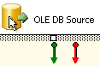  - Double-click to open the Derived column transform and expand the String Functions folder on the right.  - Drag the ‘FindString’ Function down to the first row’s ‘Expression’ column and note the other columns populate with defaults for you.  - Widen the Derived column transform window so you can see the whole FindString Expression. Note the whole expression is Red and will stay that way until we enter all needed fields.  - Expand the ‘Columns’ folder on the left, and drag ‘EmailAddress’ to the <<Character Expression>> field inside the FindString expression.  - Click on the <<String>> field and replace it with "@" (including the double quotes). So, what string are we looking for inside our character expression.  - Click on the <<Occurrence>> field and replace with a 1 (no quotes). So, find the first occurrence of the string, inside the character expression.  - Click the empty expression row below, the FindString expression should turn black as all fields are entered and of the correct data type. For example try putting “ “ around the 1, which implies string rather than numeric, then click below and see the text turn red..
5 | Add a DataReaderDest Destination to the dataflow  - This destination can be used without any configuration changes, in effect creating a ‘null’ destination. The data goes nowhere but we can trouble shoot any issue in our derived column upstream before adding any actual destinations like a SQL table or flat file.  - Because the DataReader destination is really caching the data until some other reader application pulls the data, the destination has a timeout so allow time for the reader application to pull the data. Because we only want to trouble shoot the data, we will set the timeout to 0 and execution will complete faster.  - DataReader is one of the data classes in ADO.net. So, the SSIS data streams into the SSIS DataReader Destination, and you can have some other application\component which is designed to look for\connect (hence the timeout property) using the common DataReader Interfaces. The reader application can fetch the data (read-only) and in the order it was sent down the SSIS Dataflow task. | - From the Toolbox Double-click the DataReaderDest  - Set the ReadTimeOut property to 0. This is not required as much as it makes testing easier\faster.
6 | Add a Data Viewer to the data path between the Derived Column and DataReader Dest  - The viewer shows 1 ‘buffer’ of data vs you specifying a # of rows. A buffer is part of the dataflow architecture. See BOL topic suggestions at bottom.  - Imagine using a data viewer to trouble shoot bad data…your in the viewer, see the issue and can hit the ‘Copy Data’ button to get data to the Windows clipboard which you can now paste into and fire off an email to your support team or data vendor. | - Double click the Green Data Flow path between the Derived column and destination.  - In the Data Flow Path editor click ‘Data Viewers’ on the left.  - Click the ‘Add’ button below and leave the default ‘Grid’ as the type of viewer.  - Select the ‘Grid’ tab at the top and note by default, all columns will be displayed in the viewer. Lets leave that for now.  - Click ‘ok’ and ‘ok’ again.
7 | Visually your package will look like….  - Note the little icon indicating a Data Viewer is on the path. | 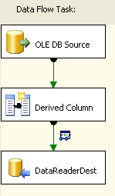
8 | Execute the Package  - You can add more than 1 viewer. Perhaps 1 full grid and another that is only 2 keys fields, and perhaps a graph.  - Data viewers are only ‘functional’ while in BIDS and do nothing and affect nothing when the package is executed at the command line with dtexec.exe  - If someone asks ‘how to trouble shoot data a row at a time’, the data viewer is the answer. Again, you cannot control the number of rows returned, its based on 1 ‘buffer’ which is a unit of measure in the SSIS memory manager. The number of rows in a single buffer depends on the column types/length as well as the number of column’s flowing down the data path. | - Save the package using the icon or from the “File” menu choose “save selected items”.  - Click the button on the toolbar or select “Debug→Start Debugging” menu option.  - The package should execute and open the Data Viewer.  - In the Data Viewer scroll all the way to the right and note the derived column we created is there and should contain a number indicating the location of the “@” symbol per row.  - Note the objects stay yellow while the data viewer is attached and open. The objects will turn green when all the buffers have been viewed and\or you close the viewer and execution can complete.  - This data set is small and not as easy to test the full data viewer functionality but you can use the green arrow to advance the data viewer to the next buffer. Detach will ‘unhook’ the viewer from the dataflow and the package will run data through until you click ‘Attach’ again (the ‘Detach’ changes values)  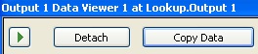  - Once the package has completed (green) you can restart execution with the button or stop execution with the button, or choose Stop and Restart from the Debug menu.
9 | Add another derived column to parse the @  - Note: if you add fields upstream after the data viewer is added you will need to re-configure the data viewer to include the new columns, or just delete it and re-add the whole viewer.  - You can attaché more than 1 data viewer to a data path. They are automatically linked such that if click on data rows on one viewer, the associated data points are selected on the graph viewer, for example. | - If you have not already, stop execution so you an edit the package further.  - Open the Derived Column transform and click the first empty row, expression field.  - Build the following expression to parse the email name. You can copy/paste from below or construct the nested expression with the editor. Note the FindString function is used as the <<Length>> field of the substring function.  SUBSTRING(EmailAddress,1,(FINDSTRING(EmailAddress,"@",1) - 1))  - Again, click below the expression when you are done and verify it turns black, indicating all fields are complete and there are no syntax errors.  - Click OK to close the derived column transform
10 | Edit the Data Viewer  - To include only our 2 derived columns and the original email field. So “EmailAddress”, “Derived column1”, and “DerivedColumn2”. | - Double click the Green Constraint data path between the Derived column and destination.  - In the Dataflow path editor click ‘Data Viewers’ on the left  - The existing Grid viewer should be selected on the right  - Click the ‘Configure’ button at the bottom  - This time, lets only have the 3 relevant columns in the viewer so remove all fields but the 3 we want using the < button or remove the all with << and then add back the 3 we want with >  - Click OK to close the data view dialog  - Click OK to close the Data Path Editor dialog
 | Execute the Package | - Save the package using the icon or from the “File” menu choose “save selected items”.  - Click the button in the toolbar or select “Debug→Start Debugging” menu option.  - The package should execute and open the Data Viewer.  - Verify the derived column is correct, the portion of the email address to the left of the “@” symbol.

Conclusion

Comments
- It pays to verify expressions, parsing, and inbound data in general before pushing it further down your flow. Discovering a mistake at the end just means that much more to edit on the way back up. This is be design overall, because each component in the flow holds meta data about the objects its dealing with as inputs and outputs. Because each component can do so much ‘locally’ with its known meta data and because the wide variety of transforms which do a wide variety of things to the local meta data, its not realistic to have changes made to one component automatically reflected up or down the flow.
- (Another Example of a Great platform. ) As an example of how great a platform SSIS is, lets look at how there are 3 basic levels to parsing….1) This lab did some basic parsing with the Derived column transform, which can handle rather sophisticated logic. However if you need very advanced parsing and per row sniffing, your best off using the 2) Script Component, which will allow you to use VB.net code, yet it’s aware of buffers and rows in the data flow task. The script component, with a bit of advanced tweaking can allow you to have one inbound row you parse in some way, to result in more than 1 outbound row. 3) for even more advanced handling or perhaps just to ease re-use, there is the Data Flow API and you can write your own custom transform for sophisticated logic OR just to make re-use easier because the custom transform can be available from the Toolbox

BOL
- “How to: Add a Data Viewer to a Data Flow”
- “Debugging Data Flow”
- “Precedence Constraints”
- “Creating a Transformation Component with Asynchronous Outputs”

Hands-on Lab II (Create text files from adventure works table then loop to load them)
- Purpose of Hands-on Lab
- The purpose is show and example of the conditional split transform, For Each Looping container, .property expressions to dynamically alter execution, and the execute SQL task with parameters to insert data into a table.
- Nice portable example of some transformations as well as file looping. Assumes the user has Adventure works installed.

Hands-on Lab Preset
- Configuration
  - We will be using data from the AdventureWorks sample database.
- Pre-stage
  - Stop execution of the previous package.
  - Close the previous package if it’s still open.

Hands-on Lab Details
 | Discussion Points | Actions taken
1 | Create a new SSIS package in the existing solution | - In the Solution Explorer right click the “SSIS Packages” folder\node and choose “New SSIS Package”  - Right-Click the new package and re-name it “LoopAndLoadProductionTable.dtsx”
2 | Create a Dataflow task and OLDE DB Source to load the [production] table.  - We could just select the table name from the list but this underscores the Source can use TSQL as well. | - With the ‘Control Flow’ canvas active, go to the Tool Box, Add and open a Data Flow task to the new package.  - Add and open an OLE DB Source to Data Flow design Canvas.  - Create a new Connection Manager to your server and the ‘Adventure Works’ database.  - Use Data Access mode of “SQL Command” and use the following  SELECT * FROM Production.ProductDescription  - Click the ‘Parse Query’ button on the right to verify your syntax  - Try the ‘Preview’ button to see a portion of the result set your SQL command will return.  - Click OK to close the OLE DB Source
3 | Add a Conditional Split transform to split the data stream based on ranges of values in the ProductionID column | - From the Toolbox, Add, Connect, and open a Conditional split transform.  - In the Conditional Split Transformation Editor, create 4 outputs (rows in the Conditional Split UI). The ‘Conditions’ are just expressions like we built with the derived column. Use the values in the table below. Again, you can type it all in, copy/paste from the soft copy of the manual or use the ‘Columns’ in the left pane, such as dragging down (to the condition row) 2 copies of [ProductDescriptionID] and then manually editing the remainder of the expression.  NOTE: you can type one then copy/paste the syntax to the next row and edit as needed.
4 | - So we will create the 4 conditions in the Conditional Split, which creates 4 outputs.  - The next step(s) we create downstream processing for each of the outputs. | Order | Output Name |  | Condition
4 |  | 1 | 1to1000 |  | ProductDescriptionID > 0 && ProductDescriptionID < 1001
4 |  | 2 | 1001to1500 |  | ProductDescriptionID > 1000 && ProductDescriptionID < 1501
4 |  | 3 | 1501to1800 |  | ProductDescriptionID > 1500 && ProductDescriptionID < 1801
4 |  | 4 | over1801 |  | ProductDescriptionID > 1800
5 |  | - Click OK to close the Conditional Split
6 | Add a Flat File Destination  - We are creating downstream processing for 1 of the 4 outputs  - We want each output from the conditional split to end/create a file. | - From the Toolbox add a Flat File Destination  - When the destination component is connected to the Conditional Split, a dialog will ask you to decide which output to use. For this first output select “1to1000” from the previous table.  - Open the Flat File Destination and note the box “overwrite data in the file” is checked so each execution will result in a unique dataset (vs. cumulative).  - Click ‘New’ to add a new connection manager of type ‘Delimited’.  - Use “ProductDescriptions1” for both Connection Manager name and description of the connection manager.  - For filename enter “C:\_SSIS_Training\LoopFiles\ProductDescriptions1.txt”  - In the window ‘Flat File Connection manager editor” Check the box “column names in the first data row’  - Check the box “Unicode” which disables the ‘Code Page’ field.  - Enter the pipe symbol “|” (<Shift>+<\>) as the text qualifier ** We want to do this because some of the descriptions in the source table contain double quotes, commas, and semi-colons which can throw off normal delimiter parsing.  - Click the Advanced page. The column “ProductDescriptionID” should be highlighted.  - Change the “Text Qualifier” property to False.  - Click the ‘Description’ Field, set the OutPutColumnWidth to 400.  - Click the “Row Guid” column Change the “Text Qualifier” property to False  - Click the “Modified Date” column Change the “Text Qualifier” property to False (we only want our “|” text qualifier to be used for the Description field\data.)  - Click OK to close the Connection Manager dialog.  - In the still open Flat File Destination Editor click ‘Mappings’ on the left. You should see the source and destination columns automatically mapped. This is one reason to trouble shoot data first, like we did in the first example.  - Click OK to close the Flat File Destination  - Note the connections listed in the Connection manager window
7 | Execute the package to insure it runs.  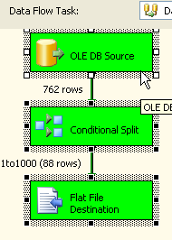 | - Save the package  - Execute the package to insure we have something similar to this image.  - NOTE: If the wrong package executes, you need to change the default object in the solution by right clicking the desired package name (“LoopAndLoadProductionTable.dtsx”) in the solution explorer and choose “Set As Startup Object’
8 | Add 3 more destinations for the other 3 outputs  - 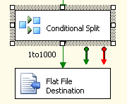 | - Add a new Flat File Destination first then link it to the upstream Conditional Split, by clicking on the Conditional Split and note you get another green data path to use\drag to the new Flat File Destination.  - Each flat file destination needs to use a unique file connection manager and point to\create a unique filename. See the table below  - Be sure to configure the other 3 Connection Managers as we did the first one .e.g. check the Unicode box, add the pipe “|” text qualifier, Check box for column names in first row, On the Advanced page…Length of Description field 400, and only the Description field has “Text Qualifier” set to TRUE.
9 |  | Path |  | Name /Description |  | Filename to use in Connection Mgr
9 |  | 1001to1500 |  | ProductDescriptions2 |  | C:\_SSIS_Training\LoopFiles\ProductDescriptions2.txt
9 |  | 1501to1800 |  | ProductDescriptions3 |  | C:\_SSIS_Training\LoopFiles\ProductDescriptions3.txt
9 |  | over1801 |  | ProductDescriptions4 |  | C:\_SSIS_Training\LoopFiles\ProductDescriptions4.txt
10 | Visually your package will look like….  - You may want to play with the auto layout option under Format>>Auto Layout>>Diagram menu option | 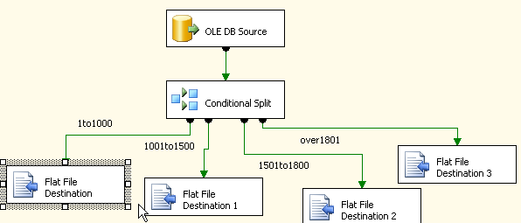
11 | Execute the package to insure it runs.  - When the package executes, you can look in the progress pane, near the bottom and note the rows written per destination, such as  [DTS.Pipeline] Information: "component "Flat File Destination" (78)" wrote 88 rows.  [DTS.Pipeline] Information: "component "Flat File Destination 1" (97)" wrote 173 rows. | - Save the package  - Execute the package to insure it runs successfully.  - NOTE: If the wrong package executes, you need to change the default object in the solution by right clicking the desired package name (“LoopAndLoadProductionTable.dtsx”) in the solution explorer, and choosing “set as startup object”.  - Browse to the destination folder C:\_SSIS_Training\LoopFiles (that was defined in the connection managers) to see the files.  - Double-click one of the files to open it in notepad and note our pipe “|” delimiter.
12 | Add and configure a For Each container  - We will now loop over the files we just created above and ‘load’ them.  - The container will return the full file name into a mapped variable.  - A variable scoped to the package (which is a container too) is more or less a global variable and visible to containers below it.  - NOTE: variables are case sensitive so for now just use all lower case to keep things easier to remember/trouble shoot. | - Stop execution of the package if you have not done so already.  - Make the Control Flow canvas (vs. Data Flow) active.  - From the Toolbox, add a ‘ForEach Loop‘ container, connect it to the Data Flow Task and open it  - On the “Collection” page use the default enumerator type of “Foreach File Enumerator”. So it will loop once per file in the specified folder.  - For “Folder” enter “C:\_SSIS_Training\LoopFiles” (no quotes)  - Leave the default “Fully Qualified” for “Retrieve File name”  - Leave the ‘Files’ to “*.*” so we grab all files in the folder.  - Change to the “Variable Mappings” page  - In the ‘Variable’ column, drop the list down and choose Add a new variable that is scoped to the top most container, which is the package itself.  - Name the variable “myfilenamefull” , leave NameSpace “user”,Value Type of “String”, and leave Value empty.  - Click “OK” to close the ‘add variable’ dialog.  - Click “OK” to close the For Each Loop Editor.
13 | Add a new user variable to hold row counts  - Later, inside the DataFlow task we will map RowCount transform to this variable, in effect storing the row count of the Data Flow Path.  - The scope of a variable cannot be changed. If you notice the scope is wrong, delete the existing variable and create a new one. If you are trying to create a package level variable, click the Control Flow canvas, (not any of the containers on it) then when you create a new variable it is assumed you are creating one at the package level. | - From the “SSIS” menu choose “Variables”. You should see the “myfilenamefull” already there.  - Click the Add new variable button . You may want to widen the variables window.  - Name should be “myrowcount”  - Scope should be the top most, of the package itself, so “Loopandloadproductiontable”.  - Data Type of int32  - Value can be left at 0
14 | Add a dataflow task  - The task will be processed once per iteration of the loop. Therefore in our case for each file in the folder the dataflow task will be executed. | - From the Toolbox add a Data Flow Task, to the inside of the loop container, and open the task. You need to drag and drop, the easier double-click method does not work when adding objects to the inside of a container.
 | Visually your package will look like…. | 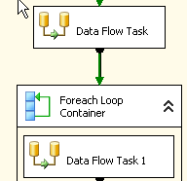
15 | Add Flat File Source and Connection Manager  - We define a single and specific file in this step, it could be to any of our existing files. After this step we will define a Property Expression on the new LoadProductDescriptions connection manager. The Property Expression will dynamically alter our connection manager to load a different file per iteration of the loop. | - Open the Data Flow Task  - From the Toolbox add a Flat File Source to the Data Flow Task, and open the Flat file Source.  - Click new to create a new Flat File Connection Manager  - For “Description” and “Connection Manager Name” enter “LoadProductDescriptions”  - For the “File Name” point to our first file “C:\_SSIS_Training\LoopFiles\ProductDescriptions1.txt” (no quotes)  - Check the box “Unicode”  - Use the default type of Delimited  - Enter the pipe symbol “|” as the text qualifier ** We want to do this because some of the descriptions contain double quotes, commas, and semi-colons which can throw off normal delimiter parsing.  - Check the box “Column names in the first data row’  - Click the “Columns” Page and see a preview of the data  - Click the “Advanced” page. The column “ProductDescriptionID” should be highlighted.  - Change the “Text Qualifier” property to False.  - Click the ‘Description’ Field, and set the OutPutColumnWidth to 400, and Change the “Text Qualifier” property to True.  - Click the column “Row Guid” and change the “Text Qualifier” property to False.  - Click the column “Modified Date” and change the “Text Qualifier” property to False. We only want our “|” text qualifier for the Description field\data.  - Click OK to close the Connection Manager dialog.  - Click OK to close the “Flat File Source Editor”.
16 | Add Column to hold name of the file processed..  - This will add a new column to our data flow, containing the filename we are processing, to each data row. Nice for auditing but obviously adds more data…  - This is a very useful feature/property but a bit hidden in that it’s not part of the advanced editor (when you double click the Flat File Source). You can only edit the property from the properties Window., which is why we had the source ‘selected’ but not ‘opened’.  - Note the advanced editor allows powerful control of the input and output of objects. Very useful when you need to go back and edit an existing package and tweak meta data in the middle of a flow. | - With the Flat File source selected, view the properties window and  - Set the “FileNameColumnName” property to “mysourcefilename”  - After you hit enter a warning icon may appear on the transform. If you hover your mouse over the transform, a tool tip will mention a meta data error.  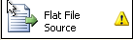  - We need to refresh the meta data. Right click the source and choose “Advanced Editor”.  - Select the ‘Refresh’ button at the bottom and click OK close the source.
17 | Add a row count transform  - To capture the # of rows processed to a variable.  - Anomaly with the rowcount transform is you have to manually type in variable names, it will not allow you to pick from a list. So, remember variable names\usage of are case sensitive. | - Add, Connect, and open a Row Count transform to the dataflow  - Enter “myrowcount” in the Variable Name property. (the variable we created earlier).  - Click “ok” to close the Row Count transform.
18 | Add Audit Transform  - To add in useful meta data to our data stream for capturing in log data, such as package name, and start time. | - Add, Connect, and open an Audit Transform to the dataflow  - In the first blank row, click the “Audit Type” column and select “Execution Instance GUID”  - Note the name is automatically filled in for you.  - Now keep adding audit types in order until you have all 9 added, so 9 rows, as seen in image below.  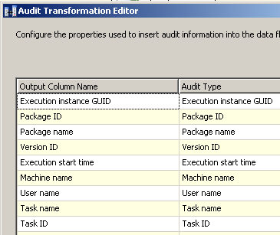  - Click “OK” to close the Audit transform
19 | Add OLE DB Destination  - To store the rows, with all of the audit information. | - Add, Connect, and open an OLE DB Destination  - Click “New” to create a new connection manager to your server, and database “SSISTRAINING”.  - After you close the Connection manager dialog, select ‘Data Access Mode’ of ‘Table or View’  - Name of existing table “mydescriptions”  - Click the “Mappings” page to insure your fields have mapped. You might want to resort the either of the 2 table field boxes to make it easier to verify the mappings. Click the top by ‘Name’ to sort  - Click “OK” to close the OLE DB destination.  NOTE: if you receive a message similar to the following, verify the Database SSISTRAINING was attached (use SQL Server Management Studio).  - Test connection failed because of an error in initializing provider. Login failed for user 'REDMOND\craigg'.  - Cannot open database "SSISTRAINING" requested by the login. The login failed.
 | Visually your package will look like….  NOTE: you can add ‘annotations’ (labels) to your flow to help with instructions. To add an annotation, right-click the design surface and choose ‘Add Aannotation’ | 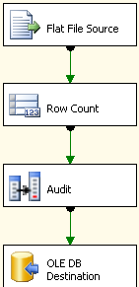
19 | Execute the Package to insure it runs  - We will loop 4 items, one for each file but we are loading the same file over and over? Why?? | - Save the package  - Have the Dataflow task open so we can watch it execute, watch the number of rows when it executes.  - Execute the package to insure it runs successfully.  - ** Did you notice the row counts were all the same? Perhaps 88?  - You can verify in the Progress Pane, looking for the rows information such as the following, repeated 4 times, with the same ’88 rows’  [Flat File Source [1]] Information: The total number of data rows processed for file "C:\_SSIS_Training\LoopFiles\ProductDescriptions1.txt" is 88.
20 | Modify Connection String to dynamically change (via property expression) with loop iterations…  - Remember the variable “myfilenamefull” we created earlier. We need that to feed our connection string per iteration of the loop, via a property expression.  - We will build another property expression in the LoadApplications sample.  - “User::” indicates the NameSpace. | - Stop execution of the package if you have not done so already.  - In the Connection manager window select (but not open) the “LoadProductDescriptions” connection manager. We want to view its properties in the property sheet not the editor window. (**)  - If the property sheet is not already visible in the right side of your screen click the button or choose “properties” from the View menu.  - In the properties pane click in the empty row for “Expressions” and then click the ellipse button  - Choose the “ConnectionString” property and click the ellipse button for the ‘Expression” column to go into the expression builder by clicking the ellipse button  - Expand the variables folder, and drag the myfilenamefull variable down to the expression, which will end up looking like the following.  - @[User::myfilenamefull]  - Click OK to close the expression builder and then OK again to close the Property Expression Editor window.  - (**) As a side/extra exercise, go to the ‘Package Explorer’ tab (same level as Control Flow and Data Flow) and find the expression you entered before.
21 | Execute the Package to insure it runs  - We will loop 4 times, one for each file. Now we should see 4 different row count results. | - Save the package  - Have the Dataflow task open so we can watch it execute, watch the number of rows when it executes.  - Execute the package to insure it runs successfully.  - You should see 4 different row counts this time. You can verify in the Progress Pane, looking for the rows  [Flat File Source [1]] Information: The total number of data rows processed for file "C:\_SSIS_Training\LoopFiles\ProductDescriptions4.txt" is 206.

Conclusion

Comments
- One of the most common uses for Property Expressions is for dynamic Connection Strings.

BOL
- “Foreach Loop Container”
- “How to: Create a Property Expression
- ”Advanced Integration Services Expressions”
- “Using Property Expressions to Specify Data Flow Property Values”

Hands-on Lab III (Expand loop to write iteration audit information)
- Purpose of Hands-on Lab
  - Provide an example of capturing execution information such as the number of rows processed, and push it into a DB with Execute SQL.

Hands-on Lab Preset
- Pre-stage
  - Uses the package “LoopAndLoadProductionTable.dtsx” built in the previous lab.
  - Stop execution of the previous package, “LoopAndLoadProductionTable.dtsx” if it’s still running.

Hands-on Lab Details
 | Discussion Points | Actions taken
1 | Add and configure an Execute SQL task to follow the DataFlow task…  - Which will be used to write per iteration information such as file name and row count, to a table | - Stop Execution of or open the package “LoopAndLoadProductionTable.dtsx”  - While viewing the Control Flow (vs Data Flow)….  - Add, Connect, and open an Execute SQL task. This is to follow/be attached to the 2nd dataflow task, the one inside the For Each container.  - Click on the “General” page  - Leave the default “Connection Type” as “OLE DB”  - For the “Connection” drop the list and choose “<New Connection>”  - Click “new” to create a new connection manager to your server “DBIL405”, and database “SSISLOGGING”. Verify with the Test Connection button.  - Click OK to close the Connection Manager window.  - Click on the “Parameter Mapping” page  - Add 5 parameters, per the image below. Note, Order is not important but the parameter names must match the variable names shown.  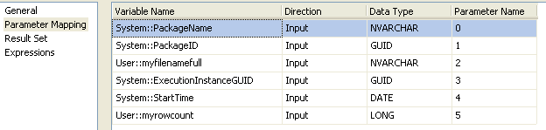  - Click on the “General” page  - Leave the default for “SQL Source Type” as “Direct Input”  - Type copy/paste the following into the “SQL Statement” property  - INSERT INTO myfileaudit (packagename,packageid,sourcefilename,executionid,starttime,[rowcount]) VALUES (?,?,?,?,?,?)  - Note: There is a ‘Parse Query’ button which can help verify your syntax in many cases, but if you click it with our current package you will likely get a message of “The query failed to parse. Parameter Information cannot be derived from SQL statements…”. This is by design in that at design time the SQL parser cannot retrieve/fill-in parameter values to replace the “?” place holders.  - Click “OK” to close the Execute SQL Task.
2 | Visually your package will look like…. | 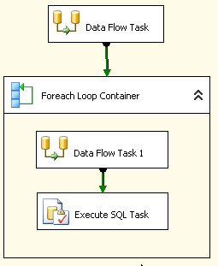
3 | Execute the Package to insure it runs | - Save the package  - Execute the package to insure it runs successfully.
4 | View the results of the audit data… | - Open SQL Management Studio, and connect to your SQL server “DBIL405”  - Expand the Databases Folder, down to the database SSISLOGGING, and table “myfileaudit”.  - Right click the table name “myfileaudit” and choose “Open Table”  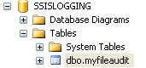  - You should see data rows, with a row count column matching the values we visually see.  - You can keep re-running the packages and refresh the query in SQL Management Studio with and see rows build up. Of course the row counts match as we are re-running the same files but the ExecutionID and StartTime should Differ for each execution.

Conclusion

Comments
- While we earlier used the audit transform to capture extra package data per row of execution (so Data Flow level auditing), you might want to also capture data at the Control Flow level, especially when there are loops. You can now see this is very easy to do with an execute SQL and the various/handy system variables.

BOL
- “Execute SQL Task”
- “How to: Map Query Parameters to Variables in an Execute SQL Task”

Hands-on Lab IV (Open a different application based on day of week)
- Purpose of Hands-on Lab
  - The purpose is to show an example of property expressions in a fringe operation, using the Execute Process task to open other applications.
  - Its also a very short exercise to walk through in case we are short on time or a student was not able to get the previous labs to execute.

Hands-on Lab Preset

Hands-on Lab Details
 | Discussion Points | Actions taken
1 | Create a new SSIS package in the existing solution | - Save and close all other open packages.  - In the Solution Explorer right click the “SSIS Packages” and choose “New SSIS Package”.  - Rights-Click the new package name and rename it “LoadAppliations.dtsx”.  - Click ‘Yes’ to rename the package object as well.
2 | Add Execute process task  - Using property expressions we will configure the single task to open a different application based on the day of the week. Open either notepad.exe or mspaint.exe depending on day of week. Using a property Expression on the 'executable' property.  - Sunday=1, Monday=2, Tuesday=3, 4=Wednesday, 5=Thursday… | - Add and open an Execute Process Task to the new package.  - Click the “Process” page  - Enter “notepad.exe” for the ‘Executable’ property.  - Click the “Expressions” page  - In the right pane click in the empty row for “Expressions” and then press the ellipse button  - Choose the “Executable” property and either copy/paste the following expression or press the other ellipse button to go into the expression builder and build this yourself. Its good practice to build and you can test this expression.  - DATEPART("weekday", GETDATE()) ==5?"notepad.exe":"mspaint.exe"  - Click “OK” as needed (2-3 times).  - Close the Execute Process task.
3 | Execute the Package to insure it runs | - Save the package, and execute.  - IF the current day is Thursday (5) then Windows Notepad will open, otherwise Paint will.  - NOTE: If the wrong package executes, you need to change the default object in the solution by right clicking the desired package name (“LoadApplications.dtsx.dtsx”) in the solution explorer  - Note: The Execute Process task is still yellow and the package is still considered ‘running’ until you close the application that opened, then the task will turn green.

Conclusion

Comments
- Property Expressions are a very powerful feature. One of the most common uses is for dynamic connection manger changes like one of the previous labs. Another is for the Send Mail Task. For example the following expression is used in a property expression on the Subject property of a SendMail task...the message will arrive with the name, start, duration information in the email subject, very handy! You can extended it and add in a variable that is populated with a Row Count transform, then without even opening the message you can see who, what, when.

"PExpression-->Package: (" + @[System::PackageName] + ") Started:"+ (DT_WSTR, 30) @[System::StartTime] + " Duration:" + (DT_WSTR,10) (DATEDIFF( "ss", @[System::StartTime] , GETDATE() )) + " seconds"

BOL
- “Using Property Expressions in Packages”
- “Execute Process Task
- “Execute Process Task Editor (General Page)”

Hands-on Lab V (Extend LoadApplications to feed it application names with a configuration file)
- Purpose of Hands-on Lab
  - The purpose is to show an example of Configuration file usage.
  - The configuration file will feed values to variables on package load, which are then mapped into the Property Expression instead of the hard coded executable names such as mspaint.exe

Hands-on Lab Preset
    - Requires the previously built package “LoadApplications.dtsx”

Hands-on Lab Details
 | Discussion Points | Actions taken
1 | Add Variables to package | - Open the existing “LoadApplications.dtsx” Package.  - From the “SSIS” menu choose ‘Variables’  - Create a string variable named “app1” with a ‘Value’ of Notepad.exe. The Scope should be the package container, so ‘LoadApplications’.  - Create a 2nd string variable names “app2” with a ‘Value’ of mspaint.exe. The Scope should be the package container, so ‘LoadApplications’.
2 | Edit the Execute process task  - Using property expressions we will configure the single task to open a different application based on the day of the week. Open either notepad.exe or mspaint.exe depending on day of week. Using a property Expression on the 'executable' property.  - Sunday=1, Monday=2, Tuesday=3.. | - Open the Execute Process Task.  - Click the “Expressions” page on the left.  - Expand the ‘Expressions’ list on the right, you should see our existing expression for the Executable property  - DATEPART("weekday", GETDATE()) ==5?"notepad.exe":"mspaint.exe"  - Either manually edit or click the ellipse button to edit the expression  - Replace “notepad.exe” with @app1 and mspaint.exe with @app2 (no quote) so the expression looks like…  - DATEPART("weekday", GETDATE()) ==5?@app1:@app2  - Click OK as needed  - Close the task
3 | Execute to insure the package behaves as it did before | - Save the package, and execute
4 | Now add an xml configuration to the package  - After you select the type of configuration you want, you select what properties of which objects are added to the configuration file.  - After the configuration is added, the SSIS execution engine knows to look at the contents of the file, during the initial load of the package, mapping the values in the file to our variables.  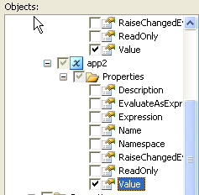 | - Stop Execution\Debugging if you have not done so already.  - From the SSIS menu choose “Package Configurations”.  - Click the “Enable Package Configurations” check box.  - Click the Add button which will launch the configuration wizard.  - Click Next  - Leave the radio button Specify configuration settings directly’ selected.  - Choose an XML Configuration file as the type.  - Enter C:\_SSIS_Training\myconfig.dtsConfig as the configuration filename.  - Click Save.  - Click Next.  - Scroll up in the objects list and find our variables app1 and app2. NOTE: If you do not see the variables listed under the package container, you likely had the scope incorrect when you created them. Go back to the variables window and verify the scope.  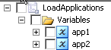  - For each, we want to drill down to and check the box for the ‘Value’ property.  - Click “Next” and you will see the confirmation page of the type and contents of the configuration.  - Click “Finish” and Close the Configuration organizer.
5 | Review and edit the configuration file contents | - You want to edit the config file, C:\_SSIS_Training\myconfig.dtsConfig  - You could use notepad.exe (you will want to choose ‘word wrap from format menu)  - Start>Run C:\_SSIS_Training\myconfig.dtsConfig  - Or use BI Studio itself, by going to the File Menu>>Open >> File  We want to find the two tag sets for <ConfiguredValue>notepad.exe</ConfiguredValue>  Which should be associated with Variables[User::app1]  <ConfiguredValue>mspaint.exe</ConfiguredValue>  Which should be associated with Variables[User::app2]  - And change the first to Calc.exe and the other to dtexecui.exe  - Save and close the file
6 | Execute the Package | - Save the package, and execute  - To Insure there are no errors. What application loaded?  - Stop package Execution and Go find the app1 and app2 variables (SSIS menu and choose variables) and see what their ‘value’ property now is

Conclusion

Comments
- You can have more than one configuration in a package, they are executed in the order you see them in the configuration organizer.
- A common practice could be to use SQL Configurations from a central DB. With SQL Configurations you can have more than 1 package from more than 1 server all using the central configuration table.

BOL
- “Package Configurations”
- “Creating Package Configurations”

Hands-on Lab VI (Error Rows and logging data)
- Purpose of Hands-on Lab
  - The purpose is to show an error flow from within the Data flow. Also an example of using a MultiFlatFileConnection manager rather than a normal one.
  - We will also add a SQL Log Provider

Hands-on Lab Preset

Hands-on Lab Details
 | Discussion Points | Actions taken
1 | Create a new SSIS package in the existing solution | - In the Solution Explorer right click the “SSIS Packages” and choose “New SSIS Package”  - Right Click the new package name and re-name it “ErrorFlow.dtsx”, answer ‘Yes’ to rename the package object as well.
2 | Add a DataFlow Task and Connection Mgr | - Add and open a Data Flow Task  - In the Connection Manager window, right click and choose “New Connection”  - Then Select the “MultiFlatFile” connection manager and click ADD  - For the Name and Description enter “badrows”  - For the Filename, browse to the folder C:\_SSIS_Training\SourceDataErrorRows  - The folder should contain 3 files with the name like “bad_data1.txt”  - Pick one of the them and click “Open”  - Click the ‘Columns’ tab and you should see some of the data, and you will likely note the first column is a numeric field and some have XX making the rows ‘bad’  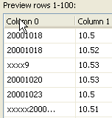  - Click the ‘Advanced’ page and change the data for column0 to “four-byte unsigned integer [DT_UI4]”  - Click ‘OK’ You should see the new connection manager in the Connection Managers window.
3 | Add a Flat File Source  - Which can use a FlatFile or MultiFlatFile connection manager | - Add and open a Flat File Source and choose the “badrows” connection manager.  - Click ‘OK’ to close the Source  - Add and connect a Data Reader Destination; again we are using it as a ‘null destination’.
4 | Test the package execution  - Does it Fail? If we look at the progress pane we can see indications of data type problem for a column and a row | - Save the package, and execute.  - NOTE: If the wrong package executes, you need to change the default object in the solution by right clicking the desired package name (“ErrorFlow.dtsx”) in the solution explorer).
5 | Now add an error flow  - This will allow us to redirect the few bad rows and continue processing the rest of the rows | - From the Toolbox, Add another Data reader Destination to the package  - Click on the Flat File Source and connect the RED line to the new data reader destination  - The “Configure Error Output” Dialog should appear.  - For “column0” change the error column from “Fail Component” to “Redirect Row”.  - Click OK to close the configure error output
6 | Execute  - Users can extend this simple example such that their error flow includes and Audit Transform and “FileNameColumnName” property of the Source connection, to then pass along good trouble shooting data to a central table  - In an Appendix you can see samples of Reporting Services reports that were built on top of a centralized Error Rows table. | - Save the package, and execute.  - NOTE: If the wrong package executes, you need to change the default object in the solution by right clicking the desired package name (“LoadAppliations.dtsx.dtsx”) in the solution explorer.  - You should see a few rows flow down the error path. (note how many do and how many flow down the green Success path.  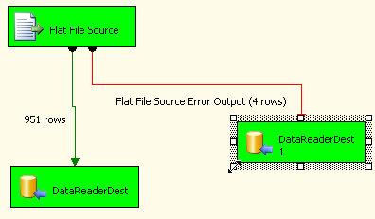  - Add a Grid Data viewer to the Error path and re-execute to view the data.  - ErrorCode users will be able to look up in Books Online.  - The ErrorColumn matches the ID you can see in the Advanced editor of the flatfile Source.  - To see the Advanced editor, (stop execution) right click the flat file source and choose ‘Advanced Editor’.  - Then click the “Input and Output Parameters’ tab.  - Expand the “Flat File Source Output”  - Then expand the “Output Columns”  - Click on column0 and the ID should match the one in the error rows  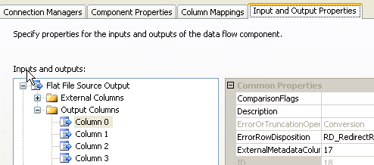  - Click OK to close the Advanced Editor.
7 | Modify the Connection Mgr to process all of the files  - The * wild card WITH the multi-flat file connection manger, will process all files that match the pattern. | - Open the BadRows connection manger.  - Change the filename to include the * wild card.  - So from  - C:\_SSIS_Training\SourceDataErrorRows\bad_data1.txt  - To  - C:\_SSIS_Training\SourceDataErrorRows\*.txt
8 | Execute | - Save the package, and execute.  - You should see more rows for both the success and error flows.
9 | Add Log Provider and details  - SSIS has a fixed table format for the logging data. You can specify which SQL Server and which database you want your data written to (via the OLE DB Connection Manager you select).  - The first time Log data is written, SSIS Will automatically create a table called “sysdtslog90”  - You can choose which log provider(s) per container. | - Stop execution if you have not already  - Go to the SSIS menu and choose Logging  - Select the log provider type “SSIS Log Provider for SQL Server”, and click ADD  - Under Configuration select <New Connection..> unless there is already one for database SSISLOGGING. If not, create on.  - Once your connection is selected/created you need to ‘check’ which containers should log data.  - In the Left, containers window, Check the Error Flow (package) and then check the Name of the provider you created  - Then check the Data Flow task and again check the Name of the provider you created  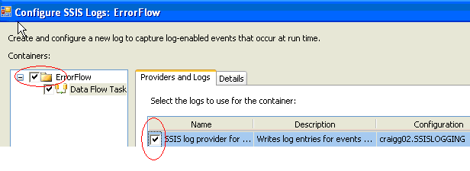  - Now click the Details tab. You can select which log entries you want. For now just check the ‘Events’ box at the top which will pick up all the log entries. Do it for each item in the Containers window, so select the contain name on the left, then ‘Events’ check box on the right.  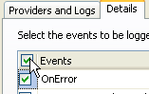  - Click on the Advanced button and note you can select which ‘fields’ you want. For now leave the default of all fields selected.  - NOTE: you can also Load and Save templates of the log entries for use later.  - Click OK to close the Logging window
10 | Execute | - Save the package, and execute.  - Visually to you, it should execute the same but now we will have rows written to our logging table.
11 | View the results of the logging data…  - In an Appendix you can see samples of Reporting Services reports that were built on top of a centralized Log provider data. | - Open SQL Management Studio, and connect to your SQL server “DBIL405”  - Expand the Databases Folder, down to the database SSISLOGGING, and table “sysdtslog90”.. If you cannot find the table there and you are sure you have executed the package, go back the logging screen and verify the settings of the chosen connection manager. Perhaps you selected one other than SSISLOGGING and therefore the table was created in a different DB.  - Right click the table name “sysdtslog90” and choose “Open Table”  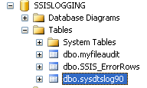  - You should see logging rows. Note there are very useful fields like executionid which allows you to differentiate multiple executions of the same package.  - You can keep re-running the package and refresh the query with and see rows build up. Of course the row counts match as we are re-running the same files but the ExecutionID and StartTime should Differ for each execution

Conclusion

Comments
- So now we have seen 2 different approaches to processing multiple file, using a loop container and a multi-flat file connection manager. One is not more ‘correct’ than the other, just depends on the application. With a large number of files the loop structure approach would take longer because it needs to start/close the data flow engine each time vs. the other approach where only 1 data flow is used. However, the loop approach does provider more flexibility in the control flow, for example you can take action after each file

BOL
- “Using Error Outputs”
- “Integration Services Log Providers”
- “Implementing Logging in Packages”

Hands-on Lab VII (Deploy packages and execute from Management Studio)
- Purpose of Hands-on Lab
  - The purpose is to show an example of deploying packages with the SSIS deployment utilities.
  - This process essentially just copies files to a desired location, which could be SQL or file system share.

Hands-on Lab Preset
- Uses Solution and packages created in previous labs. You do not need them all to complete this exercise but if you did not complete the configuration file exercise of the LoadApplications package, the configuration information\exercise in this lab will not apply.

Hands-on Lab Details
 | Discussion Points | Actions taken
1 | Configure Deployment for the solution.  - Specify where to build the deployment file set and turn on the set creation to occur when the solution is built.  - “AllowConfigurationChanges” controls if the Installation wizard will prompt for changes to values currently in a configuration file, during the installation. | - Close all open packages in your Solution  - From the “Project” Menu choose “SSISTraining Properties”, the name of your solution. (it might say just ‘properties’ if you have added more than 1 project to the solution)  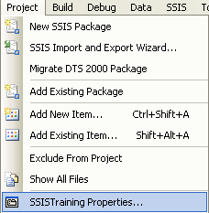  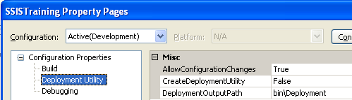  - Click the ‘Deployment Utility’ tab  - Set the “AllowConfigurationChanges” to True  - Set “CreateDeploymentUtility” to True  - Leave the “Deployment Output Path” set to ‘bin\Deployment’. This will be a subfolder under our solution  - Click OK to close the “SSISTraining Property Pages”
2 | Build the solution and Deployment files  - When you ‘build’ the solution SQL Development Studio will create the deployment file set which includes all of the packages from the Solution, configuration files that are associated with packages, as well as any files you may have in the “Miscellaneous” folder of your solution. This is a handy want to insure a readme file is deployed with your package  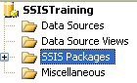 | - From the Build Menu choose “Build SSISTraining”  - If you look in the output window you should see results similar to the following screen shot. If the Build menu is not visible goto menu View>>Other Windows>>Output.  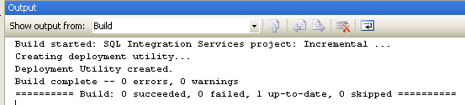
3 | Review the Deployment File Set  - Users can then copy\move the file set to where they want to run deployment from. That machine needs to have SSIS installed to deploy, or else it will not recognize the manifest file. | - Go view the folder where our files were gathered  C:\_SSIS_Training \SSISTraining\bin\  - You will see our packages (*.dtsx), the configuration file we created, and a manifest file that is used to perform the actual deployment.
4 | Install Package (Deploy) to another folder on the same machine  - From the desired deployment machine, a can now run the manifest file and deploy (copy) packages to any file share or SQL server where they have permissions.  - Keep in mind the packages can only execute on machines that have SSIS installed (dtexec.exe) | - In file explorer double click the manifest file “SSISTraining.SSISDeploymentManifest”  - In the Package installation wizard, Choose File System deployment.  - Click Next  - Use the default file path  - C:\Program Files\Microsoft SQL Server\90\DTS\Packages\SSISTraining  - Click Next  - The Installer will note it has enough information to install, click Next  - The install will run a bit then should pause at a “Configure Packages” Screen’  - For now just leave the existing values, calc.exe and dtexecui.exe, click Next  - This is screen would allow you to change current configuration values as you install. For example if you had configured connection managers, you can change each installation for appropriate server names, without physically altering the package itself.  - Note on the ‘Finish’ Screen the log information about the Installation.  - Click ‘Finish’ to complete and close the installation.
5 | Execute Package using DTEXECUI.exe | - You can browse to the folder where you deployed and double click a package to open DTEXECUI.exe for that package.  - You can use DTEXECUI to execute the package directly (Execute button on bottom) or build a command line for use in a batch file, agent, other process.  - When you execute via DTEXECUI.EXE you will see a progress window (below)similar to what you see in SQL BI Studio. When you execute directly with dtexec.exe from a command prompt, you will not see that window though dtexec.exe supports many switches including console reporting. See help topic suggestions at the end of this lab.  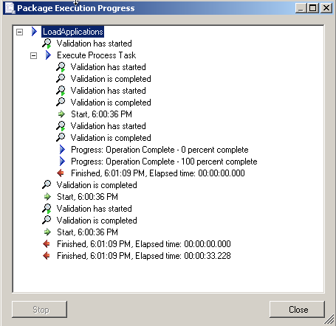
6 | Deploy to SQL Sever  - The Installation wizard will not convert an XML configuration file to SQL configuration when you install the package to SQL sever, by design. | - Run the Installation wizard again (double click the manifest file)  - This time choose “SQL Server Deployment”  - Choose your local server “(local)” or the name if the server, and windows authentication.  - Click ‘Next’  - The next screen is regarding package dependency files (configuration, miscellaneous). Even though the package is going into SQL, the configuration files still need a file location default should be fine. Click ‘Next’  - Click ‘Next’ on the ‘Confirm Installation’ screen.  - Click After the ‘enough information’ wizard you will see the screen for editing configuration values. You can experiment with other execution file name if you like. OR just leave what’s there and click Next.  - And Finish on the Finish Installation screen.
7 | Open SQL Management Studio to see and execute the packages you just installed to SQL | - Open SQL Server Management Studio, connect to your local SQL box with the initial connection dialog.  - Once in Mgt Studio, connect to you local SQL Server Integration Services, server. One way is to double click the name in the ‘Registered Servers’ pane  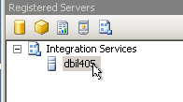
8 | Find and execute package “LoadApplications” | - Expand the Stored packages folder down to your packages in MSDB  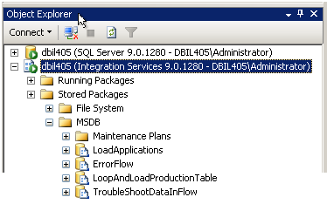  - Right Click the “LoadApplications” package and choose “Run Package”  - DTEXECUI.exe runs and is pre-populated with the package information.  - Execute the package using the Execute button on the bottom.  - If we left the package configuration file as is, another instance of dtexecUI will likely load (it was the value of “app2”)  - Before you close dtexecui (or whichever application loaded), go to the “Running Packages” node in SQL Management Studio. You should see your package listed there.  - If you click the running package name and then the “Report” button in the right pane, you will see details about the currently executing package, such as Package name, Start Time….

Conclusion

Comments
- The 2nd level of Folders found in the SQL Mgt Studio ‘Stored Packages folder’ can be controlled by the user via a configuration file used by the SSIS Windows Service. The default file installed, ships with folder names “MSDB” and “Maintenance plans” but the user can create whatever XML configuration (service configuration not package configuration) file they like, and then modify a registry key to tell the SSIS service, on Service start, what file to load and where its located. See BOL topics.

BOL
- “Creating a Deployment Utility”
- “How to: Create an Integration Services Package Deployment Utility”
- “Installing Packages”
- “How to: Run a Package Using the DTExecUI Utility “
- “Command Prompt Utilities (SSIS) “
- “Configuring the Integration Services Service”
- “Scheduling Package Execution in SQL Server Agent”

Hands-on Lab VIII (Add Execute SQL to truncate table to the LoopAndLoadProductionTable package)
- Purpose of Hands-on Lab
  - The purpose is to show an example of the Execute SQL task to truncate the table ‘mydescriptions’ prior to loading of new data
  - Because SSIS is a platform, you can easily create packages that focus Database maintenance such as truncate, drop, attach, move. The “Maintenance Plans“ feature found in the tree [your server name]\Management folder of SQL Management Studio, uses SSIS tasks under the hood.

Hands-on Lab Preset
- Uses the package LoopAndLoadProductionTable.dtsx that was built earlier in the lab

Hands-on Lab Details
 | Discussion Points | Actions taken
1 | Verify number of rows in the table ‘mydescriptions’ | - We want some data in the table ‘mydescriptions’ so execute the ‘LoopAndLoadProductionTable.dtsc’ package several times prior to executing this lab.  - Use SQL Management Studio to find the table ‘mydescriptions’ in the ‘SSISTRAINING’ database, and verify the number of rows in the table (right click the table name and select ‘Open Table’)
2 | Add and configure an Execute SQL task  - This will clear all the rows in the ‘mydescriptions’ table | - While viewing the Control Flow (vs Data Flow)  - Add, Connect, and open an Execute SQL task. This is to precede the 1st dataflow task  - Leave the default “Connection Type” as “OLE DB”  - For the “Connection” drop the list and choose the connection manager for the SSISTRAINING Database  - Leave the default for “SQL Source Type” as “Direct Input”  - Type copy/paste the following into the “SQL Statement” property. This is a straight forward SQL statement and a good one for using the ‘Parse Query’ button to validate your syntax.  truncate table mydescriptions  - Click “OK” to close the Execute SQL Task.
3 | Visually your package will look like…. | 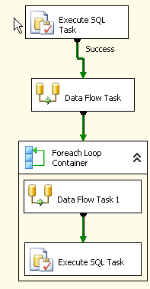
4 |  | - Save the package  - EXECUTE  - Verify the number of rows now in the ‘mydescriptions’ table  - NOTE: If the wrong package executes, you need to change the default object in the solution by right clicking the desired package name (“LoadAppliations.dtsx.dtsx”) in the solution explorer.
5 | Disable the new Task  - In the Control Flow, right click the New Execute SQL task and choose ‘Disable’. Notice the task turns gray (see image). Now when you execute the package the execute SQL is ignored.  - THIS IS A GOOD DESIGN TIP\Practice in some scenarios to have little maintenance like tasks built into your package but disabled. Then they are there for maintenance/trouble shooting as needed | .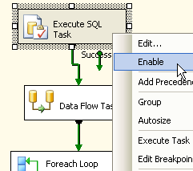  Now you should be able to run the package several times in a row, see the number of rows increasing in the table, then enable the task and disable the others to verify the table is clean.  ** Out of class, little extra work. Add a Sequence container to the package, it will contain your first DataFow task, ForEach Loop, and the Inserting Execute SQL task…which makes it easy to disable all of the at once (by disable the sequence container). Great if you want to disable everything but the ‘truncating’ Execute SQL, use it to truncate all of the data, then reverse what is enabled/disabled and continue on.  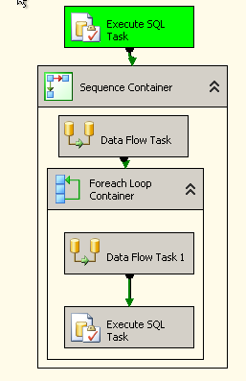

Comments

BOL
- “Maintenance Tasks “
- “Execute SQL Task “

Appendix A Where to learn more
- The SSIS portal on MSDN. Lots of great information including white papers, Webcasts, recommended books.
http://msdn.microsoft.com/SQL/sqlwarehouse/SSIS/default.aspx

- SSIS Support Forum on MSDN (moving away from newsgroups)
http://forums.microsoft.com/msdn/showforum.aspx?forumid=80

- Of course the excellent SQL Server Books Online which ship with the product. You\customers can also download a separate copy. Handy for initial investigations when they want some details on specific features but are not ready yet to install and play with the product.
http://www.microsoft.com/downloads/details.aspx?FamilyId=F0D182C1-C3AA-4CAC-B45C-BD15D9B072B7&displaylang=en

Appendix B sample Reports for SSIS Log Providers (OnPipeline Rows sent and
These are just examples of Reporting Services Reports you can create based on the data. SSIS is a data integration platform that includes various ways to produce detailed ‘instance data’ (Logging, Error Rows, and Audit Information in flow) which customers can pull together in whatever way best suits them. One reason why there is not a detailed/fixed support console like application. Every customers needs are different and we provide the data. The examples here were built in SQL 2005 Reporting Services and will be available at some point for customers, downloadable or via a RS report pack.

General Log summary, history, results.
Report showing summary of package executions results/history across machines. This is supported by all packages executing on various machines all using the same SQL Log provider destination, providing central log collection and reporting.
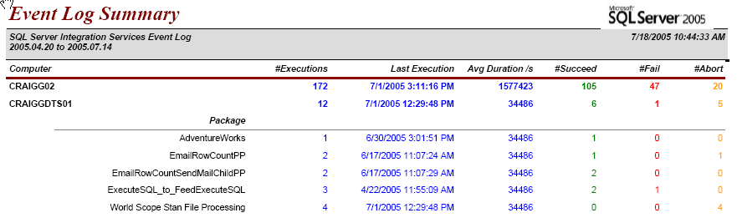

Detailed package log history report
A More detailed report including a graph of execution instance vs execution duration.
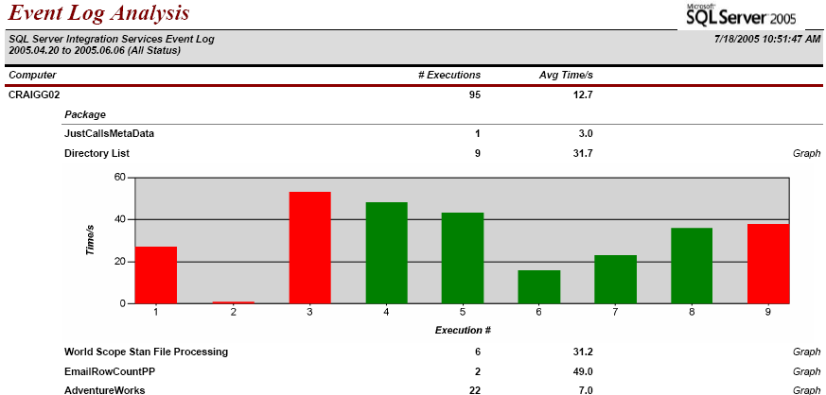

Detailed Pipeline report
This report is low level, based on the even OnPipelinRowsSent event that can be logged (if you turn it on in the log provider window).
The report is showing the number of rows that passed through the data paths and components for dataflow task, per execution. A customer may find this information very useful to review over time and may want to create a data warehouse with these sorts of results
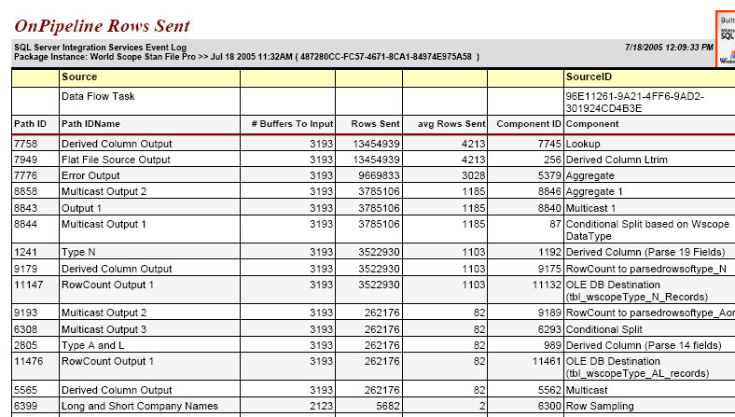

Error Row Report
The following report is against a central table containing data from Error Row data from Data Flow Tasks.
